Hotel Management System

**Software Requirements Specification**

Version 1.0

Danang, Sept 2024

**TABLE OF CONTENTS**

**TABLE OF CONTENTS** 2

1. DOCUMENT HISTORY 4

2. REFERENCE DOCUMENTS 4

3. INTRODUCTION 4

3.1 Purpose 5

3.2 In Scope 5

4. REQUIREMENT 5

5. OVERVIEW 6

5.1 Actors 5

5.2 System Use Case Diagram 6



5.3 System Pages Flow 6

6. SCREEN DESIGN 13

7. Data Structure 18

7.1 Entity Diagram 18

7.2 Database 18

8. NON-FUNCTIONAL REQUIREMENTS AND OTHERS 25

Performance 25

Security 25

Design Constraints 25

Standards Compliance 26

Reliability 26

Availability 26

Maintainability 26

Portability 26

9. APPENDIX

# **DOCUMENT HISTORY**

| **Date** | **Summary of Changes** | **Version** |
| --- | --- | --- |
| 17/09/2024 | Maintain software requirements for hotel management system | RMS_SRS_sample_v1.0 |

# 

# **REFERENCE DOCUMENTS**

| **Document Name** | **Description** |
| --- | --- |
| [1] Software Modeling and Design | Reference document |

# 

# **INTRODUCTION**

The following subsections of the Software Requirements Specifications (SRS) document provide an overview of the entire SRS.

## ***Purpose***

* The Software Requirements Specification (SRS) will provide a detailed description of the requirements for the Hotel Management System (HMS). This SRS will allow for a complete understanding of what is to be expected of the HMS to be constructed. The clear understanding of the HMS and its functionality will allow for the correct software to be developed for the end user and will be used for the development of the future stages of the project. This SRS will provide the foundation for the project. From this SRS, the HMS can be designed, constructed, and finally tested.
* This SRS will be used by the software engineers constructing the HMS and the hotel end users. The software engineers will use the SRS to fully understand the expectations of this HMS to construct the appropriate software. The hotel end users will be able to use this SRS as a “test” to see if the software engineers will be constructing the system to their expectations. If it is not to their expectations the end users can specify how it is not to their liking and the software engineers will change the SRS to fit the end users’ needs.

## ***In Scope***

* The software product to be produced is a Hotel Management System which will automate the major hotel operations. The first subsystem is a Reservation and Booking System to keep track of reservations and room availability. The second subsystem is the Tracking and Selling Food System that charges the current room. The third subsystem is a General Management Services and Automated Tasks System which generates reports to audit all hotel operations and allows modification of subsystem information. These three subsystems’ functionality will be described in detail in section 2-Overall Description. There are two end-users for the HMS. The end users are the hotel staff (customer service representative) and hotel managers. Both user types can access the Reservation and Booking System and the Food Tracking and Selling System. The General Management System will be restricted to management users.
* The Hotel Management System’s objective is to provide a system to manage a hotel that has increased in size to a total of 100 rooms. Without automation the management of the hotel has become an unwieldy task. The end users’ day-to-day jobs of managing a hotel will be simplified by a considerable amount through the automated system. The system will be able to handle many services to take care of all customers in a quick manner. The system should be user appropriate, easy to use, provide easy recovery of errors and have an overall end user high subjective satisfaction.

# **REQUIREMENT**

***4.1 Purpose***

+ Customer management

+ Booking Room and reject Room management

+ Room status’s management

+ Service management

+ Expense management

+ Staff management

***4.2 Requirement specification***

***4.2.1 The organisation of hotel***

Department with the highest power is the board of directors, the board of directors includes many people divided by three main tasks: Room and other services, financial management, security and maintenance. Room management and other services management includes the following departments: Reception, Room department, bar, kitchen, service rooms (such as laundry, sauna ...). The financial management includes: Department of Finance and Planning, Administration and General Affairs. Maintenance protection includes: guard and maintenance rooms.

***4.2.2 Booking room flow***

***4.2.2.1 Booking***

When a customer books a room, in many ways, by phone or direct apparently, the Reception will check rooms for the customer's requirement (on room type and price). If hotel has the room that customer requires, the receptionist will take to receive reservation procedure by obtaining the necessary information of customers, including:

- Amount of people

- Customer name

- Nationality

- Phone number

- How many room needed and room category

- Payment method

- Arrive date

- Leave date

Receptionists also ask customers with information assurance (usually prepay a portion of cash or certain reputation, due to referral or patrons). The bill will be sent to the customer. If the reservation time is too long, the previous overbooking reservations due date, the hotel will get back to the hotel again to check to make sure other viewers also demand reservation again and again to update the booking status. Based on the list above that guests booking a day Reception will predict the booking department a relative number of rooms to be prepared to welcome visitors through the preparation with the following contents:

- The total amount of customers

- Room price

- The amount of room

- The customer per room

***4.2.2.2 Receive Room***

When a customer receive room, the receptionist write their information with the following field

**With International customer**

- RoomID

- Customer name

- Nationality

- Birthday

- Passport

- Visa number

- The name of the tourist company

- Arrive date

- Leave date

**With local customer**

- Customer name

- Birthday

- Identity number

- Countryside

- Arrive date

- Leave date

If a customer is a walk-in guest, the receptionist can hold customer prepay-money and hold until payment. If this amount of money is too large, the receptionist will give it to the financial department. After that Reception will store information about visitors, give it to the Room department by sending the contract to the chamber room. The contract includes the following information:

- The amount of people and gender

- Nationality

- Receive date

- Leave date

- Room number

- Room price

- Service

- Check out date

***4.2.2.3 Leaving at hotel***

During staying at the hotel, all requirements for physical facilities of the hotel will be reported directly to the Receptionist, the loan services that will be recorded by the receptionist to remind visitors to pay when checking out. When guests want to switch rooms, the receptionist shall have procedures for customers then report back to the housekeeping department to update the customer information. If customers use other services of the hotel and want to share the amounts paid upon check out, guests must sign a agreement as follows:

- Customer name

- Company name

- Tax code

- Service name

- Price/Service

- Total

***4.2.3 Service management***

***4.2.3.1 Restaurant service***

- Customers order meal

- Expose bill for customers

- Customers choose payment method

***4.2.3.2 Bar service***

As the same at Restaurant service

***4.2.3.3 Laundry service***

Only for clients staying in the hotel.

- Customer requests the assistance to launder

- Once done, Housekeeping department gives customer an invoice confirmation

- Customer Pay the fee when check out

***4.2.4 Staff management***

***4.2.4.1 Room and Service management***

+ Confirm the reservation.

+ Check in for customers.

+ Payment check, transferred to the financial department.

+ Receiving complaints and answering questions, resolving customer requirements.

+ Regularly check the rooms, responsible for preparing equipment in the room.

+ Provide other services such as dining, entertainment, laundry, transportation, ...

***4.2.4.2 Finance management***

+ Financial management, renting payments and other services.

+ Management of employee salaries.

***4.2.4.3 Security and maintenance***

+ Hotel security guard.

+ Maintenance and replacement (if necessary) of the equipment in the room.

***4.2.5 Staff management***

+ Staff name

+ Staff code

+ Department

+ Salary

+ Shift

# **OVERVIEW**

## ***Actors***

+ Customer

+ Manager

+ Guest

## ***System Use Case Diagram***

## 

## ***System Pages Flow***

***5.3.1 Management flow***

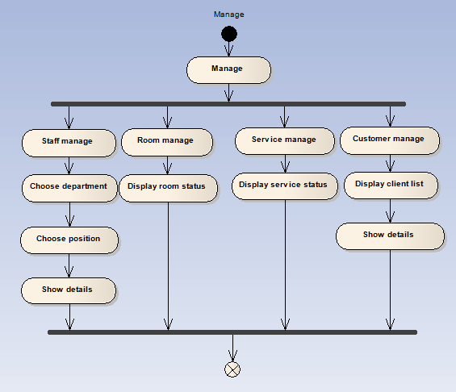

***5.3.2 Booking room flow***

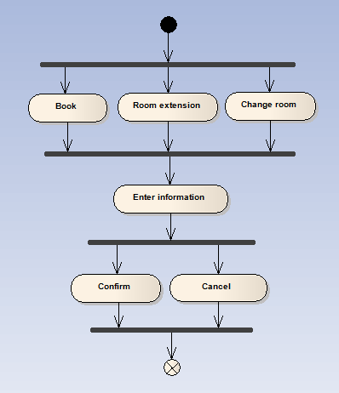

***5.3.3 Service providing flow***

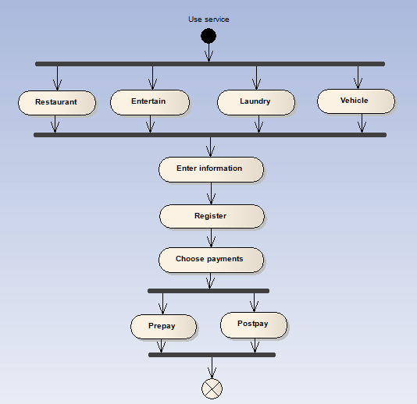

# **SCREEN DESIGN**

**+ Login**

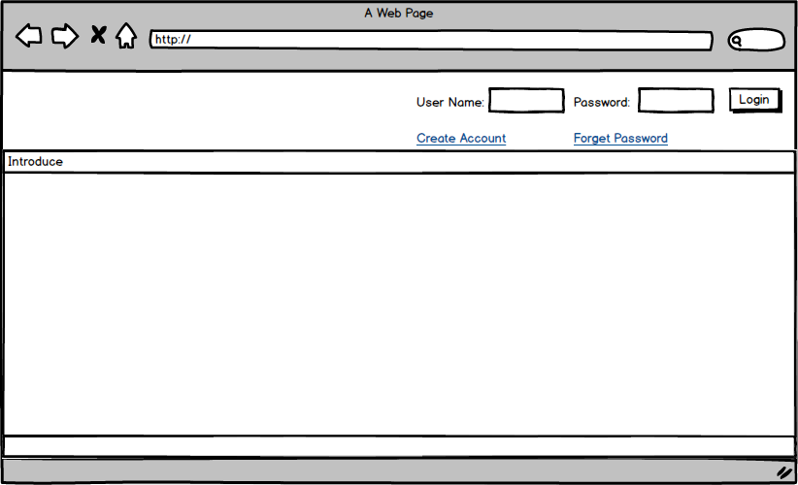

| **Screen** | Login screen | | | |
| --- | --- | --- | --- | --- |
| **Description** | Input your user name and password to login your account. If you do not have any account, you can click the Create account link to create a new account or click to Forget password to be helped. | | | |
| **Screen Access** | Default | | | |
| **Screen Content** | | | | |
| **Item** | | **Type** | **Data** | **Description** |
| User Name | | Textbox | Export From Database | Here, input your username |
| Password | | Textbox | Export From Database | Input your password for your user name that you submitted. |
| Login | | Button |  | To login, After finish typing username and password, click this button. If the user name or password was wrong, you can’t access the account. You must retype and try again. |
| Creat Account | | Link |  | To create a new account, you click here. New create account layout will show. |
| Forget Password | | Link |  | When you forget your password, click here for help |

**+ Creat new account layout**

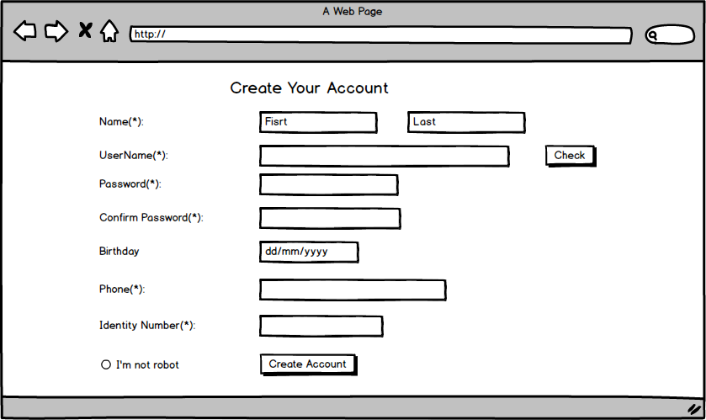

| **Screen** | Create account | | | |
| --- | --- | --- | --- | --- |
| **Description** | | If you want to create a new account, this screen will show you how. From the login screen, click create account link to view this layout. After inserting yourself information, click the Create Account button to register a new account with OS. | | |
| **Screen Access** | | Users click on create account link from login layout. | | |
| **Screen Content** | | | | |
| **Item** | | **Type** | **Data** | **Description** |
| Name | | textbox | Insert your name (First name & last name) | Type text |
| Username | | textbox | Insert your elective user name. | Type text. |
| Check | | textbox | Check database | Click the button to check if the username was registered. You must be type another until os accept |
| Password | | textbox | Insert your register password. | Type text |
| Confirm Password | | textbox |  | Retype password from password item |
| Birthday | | Textbox (dd/mm/yyyy) | Insert your birthday | Type your birthday. |
| Phone | | Textbox (number) | Insert your phone number | Insert your cell phone |
| Identity Number | | Textbox (number) | Insert your identity number | Insert your identity number to confirm yourself. |
| I’m not robot | | Radio button |  | Click or not |
| Create Account | | button |  | Click it to fishnish the create account process. If there is an empty item, you have to comply to fishnish. |

**+ Booking room**

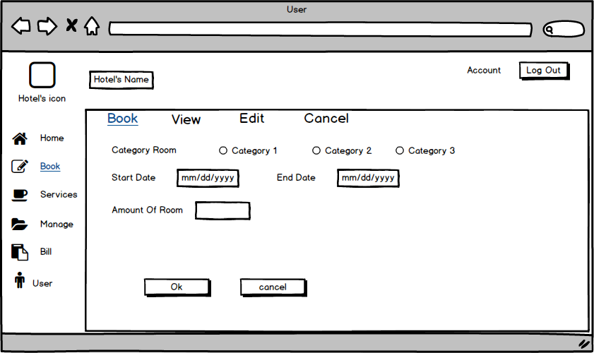

| **Screen** | Book | | | |
| --- | --- | --- | --- | --- |
| **Description** | | Describe how and what to do when you are booking room by your account on Hotel’s website | | |
| **Screen Access** | | Click Book from the Book menu. ( Or default) | | |
| **Screen Content** | | | | |
| **Item** | | **Type** | **Data** | **Description** |
| Hotel’s icon | | Image box |  | Insert image of the hotel. |
| Hotel’s name | | Label |  | Insert name of the hotel. |
| Log out | | Button |  | Click the Logout button to log out of the account, and complete a session. |
| Category room | | Radio check |  | Show 3 kinds of room for you to choose one. |
| Start day | | Textbox |  | Insert date you start stating the hotel |
| End day | | Textbox |  | Insert date you are going to leave. |
| Amount of room | | Number |  | Insert here how much do you want to reserve. |
| Ok | | button |  | Click Ok, You will submit a new reservation. Its ok if you entire the proposed box. If not, you have to complete the text. |
| Cancel | | button |  | Cancel the booking room session when you click Cancel button here. |

**+ Booking (view)**

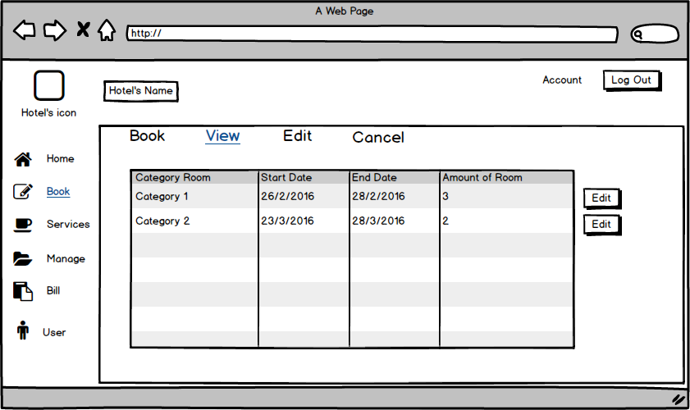

| **Screen** | View | | | |
| --- | --- | --- | --- | --- |
| **Description** | | It shows booking information. Here you can see what you were registered in, and you can change if you want. You click the edit button to show the edit screen. | | |
| **Screen Access** | | Click the view item from the Book menu. | | |
| **Screen Content** | | | | |
| **Item** | | **Type** | **Data** | **Description** |
| Table | | List data | Export from database | Describing information about the register room of the user. |
| Edit | | Button |  | Button to change your register. |

**+ Booking (edit)**

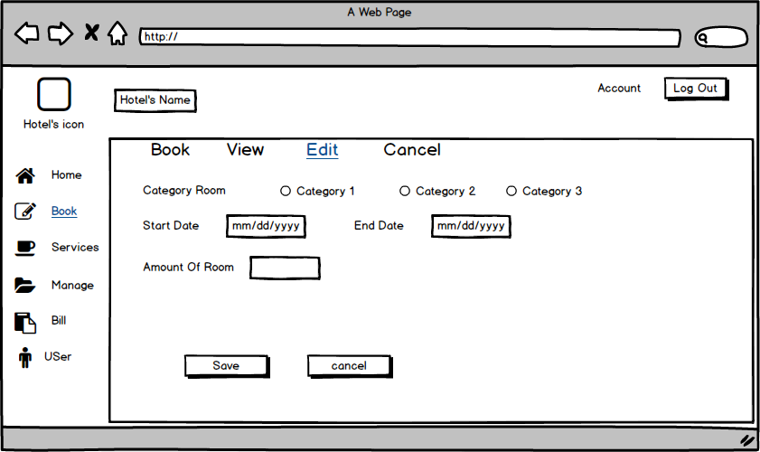

| **Screen** | Edit | | | |
| --- | --- | --- | --- | --- |
| **Description** | | Update or register again. Click save or cancel to finish | | |
| **Screen Access** | | Click edit item from Book menu | | |
| **Screen Content** | | | | |
| **Item** | | **Type** | **Data** | **Description** |
| Category room | | Radio checkbox |  | Show 3 kinds of rooms to choose. You can choose one of them |
| Start day | | Textbox |  | Insert start day follow format |
| End day | | Textbox |  | Insert end day follow format |
| Amount of room | | Number |  | Insert amount of room you want to register |
| Save | | Button |  | Click it to Save and update information in this Form. The old data will be deleted before updating the new data. |
| Cancel | | button |  | Click this to cancel the update, the data don't delete. |

**+ Booking (Cancel)**

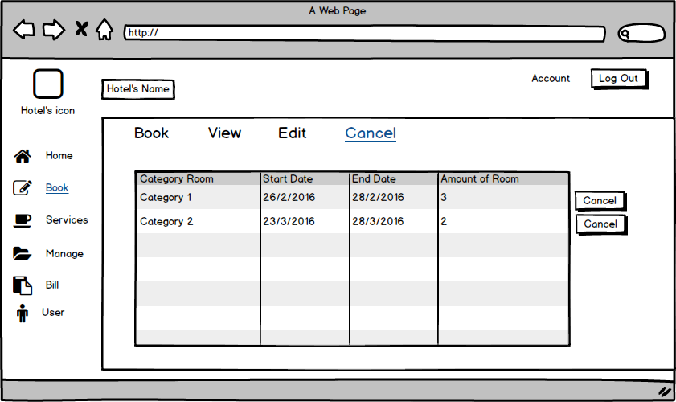

| **Screen** | Cancel | | | |
| --- | --- | --- | --- | --- |
| **Description** | | Update or register again. Click save or cancel to finish | | |
| **Screen Access** | | Click edit item from Book menu | | |
| **Screen Content** | | | | |
| **Item** | | **Type** | **Data** | **Description** |
| Table | | table | Export from database | Describing information about the register room of the user. |
| Cancel | | Button |  | Click here if you want to Cancel your register before. When the Cancel button is clicked, it will show you a dialog box to confirm your decision. |

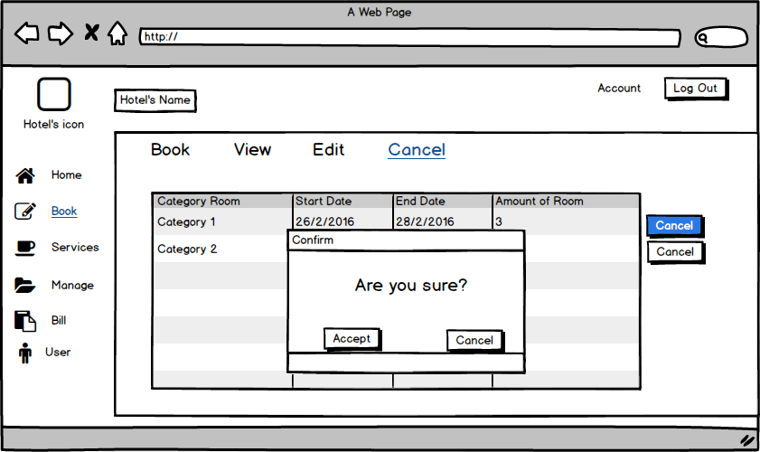

| **Screen** | Cancel | | | |
| --- | --- | --- | --- | --- |
| **Description** | | Update or register again. Click save or cancel to finish | | |
| **Screen Access** | | Click edit item from Book menu | | |
| **Screen Content** | | | | |
| **Item** | | **Type** | **Data** | **Description** |
| Accept | | button | List menu | If you click this button then the data in the table will be deleted, also in the database. Return to the Cancel screen but you will not see the table anymore . |
| Cancel | | button | Day, month, year (d/m/y) | Click the Cancel button. Return Cancel screen, and nothing is changed. |

**+ Service (Restaurant)**

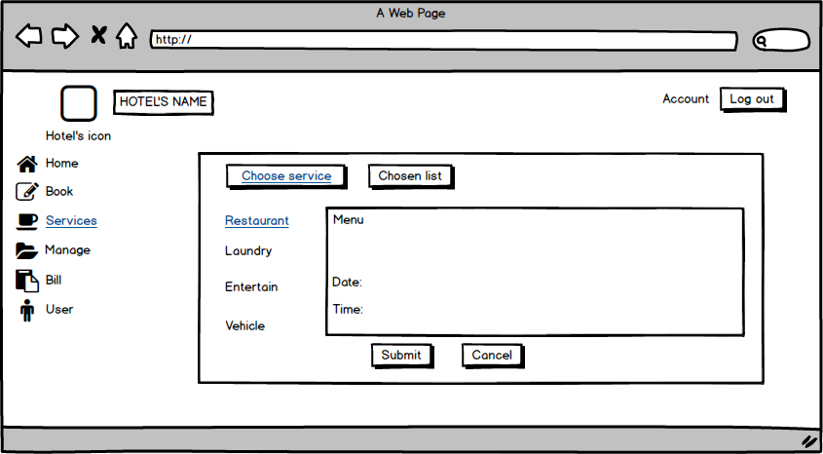

| **Screen** | Service Restaurant | | | | |
| --- | --- | --- | --- | --- | --- |
| **Description** | | Displays a list of the dishes, drinks and date, time. | | | |
| **Screen Access** | | Users click Submit, Cancel or Chosen list on Screen. | | | |
| **Screen Content** | | | | | |
| **Item** | | **Type** | **Data** | **Description** | |
| Menu | | Text | List menu | Display information of the list menu. | |
| Date | | Date | Day, month, year (d/m/y) | Display information of the day. | |
| Time | | Time | Time (h:m) | Display information of the year. | |
| Submit | | Button |  | Submit | |
| Cancel | | Button |  | Cancel | |
| **Screen Actions** | | | | | |
| **Action Name** | | **Description** | | **Success** | **Failure** |
| Submit | | Click Submit to select menu list. | |  |  |
| Cancel | | Click Cancel to cancel | |  |  |
| Chosen list | | View chosen list | | Display a selected list |  |

**+ Service (Chosen list)**

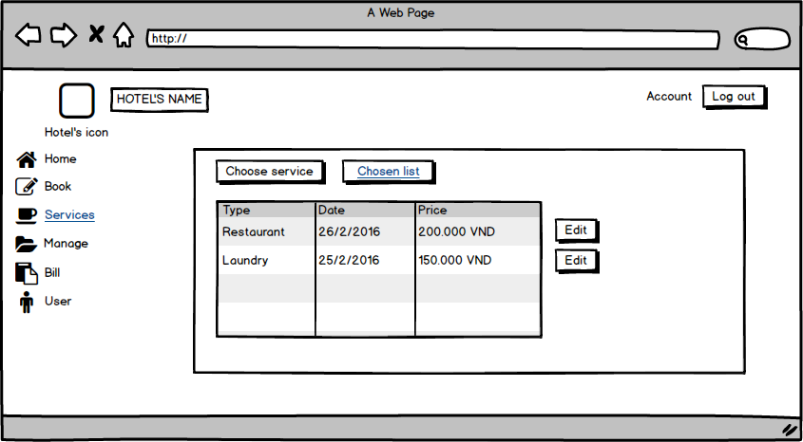

| **Screen** | Service Chosen list | | | | |
| --- | --- | --- | --- | --- | --- |
| **Description** | | Displays Chosen list. | | | |
| **Screen Access** | | Users click edit button on Screen. | | | |
| **Screen Content** | | | | | |
| **Item** | | **Type** | **Data** | **Description** | |
| Type | | Text | Service list | Display information of service. | |
| Date | | Date | Day, month, year (d/m/y) | Display information of the day. | |
| Price | | Float | Money | Display Price. | |
| Edit | | Button |  |  | |
| Chosen list | | Button |  | Chosen list | |
| Choose service | | Button |  | Choose service | |
| **Screen Actions** | | | | | |
| **Action Name** | | **Description** | | **Success** | **Failure** |
| Edit | | Click Edit to edit information of services. | |  |  |

**+ Service (Laundry)**

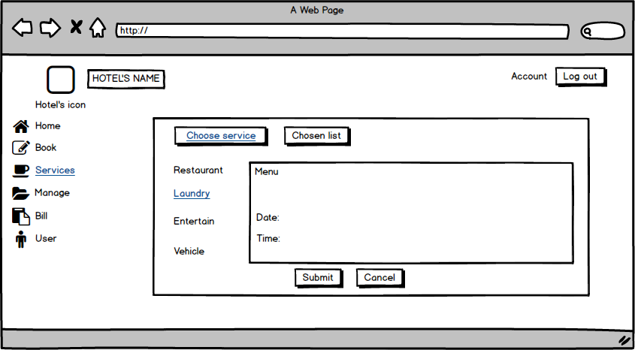

| **Screen** | Service Laundry | | | | |
| --- | --- | --- | --- | --- | --- |
| **Description** | | Displays a list of the service laundry. | | | |
| **Screen Access** | | Users click Submit, Cancel or Chosen list on Screen. | | | |
| **Screen Content** | | | | | |
| **Item** | | **Type** | **Data** | **Description** | |
| Menu | | Text | List menu | Display information of the list menu. | |
| Date | | Date | Day, month, year (d/m/y) | Display information of the day. | |
| Time | | Time | Time (h:m) | Display information of the year. | |
| Submit | | Button |  | Submit | |
| Cancel | | Button |  | Cancel | |
| **Screen Actions** | | | | | |
| **Action Name** | | **Description** | | **Success** | **Failure** |
| Submit | | Click Submit to select menu list. | |  |  |
| Cancel | | Click Cancel to cancel | |  |  |
| Chosen list | | View chosen list | | Display a list of selected |  |

**+ Service (Entertainment)**

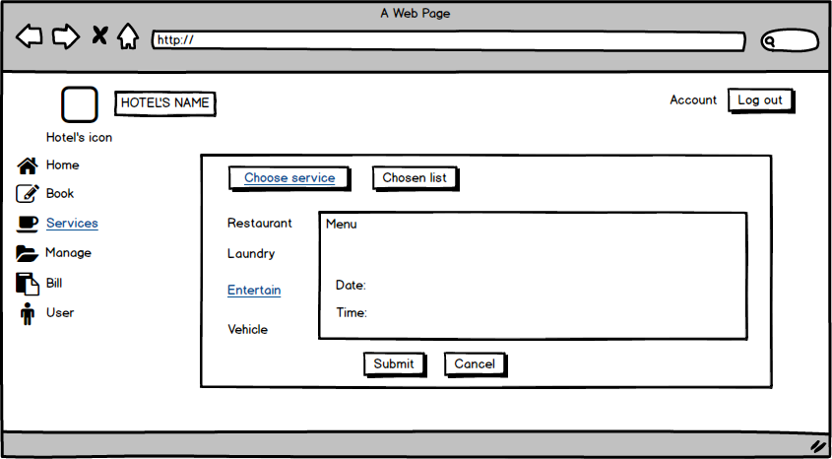

| **Screen** | Service Entertainment | | | | |
| --- | --- | --- | --- | --- | --- |
| **Description** | | Displays a list of the Service Entertainment. | | | |
| **Screen Access** | | Users click Submit, Cancel or Chosen list on Screen. | | | |
| **Screen Content** | | | | | |
| **Item** | | **Type** | **Data** | **Description** | |
| Menu | | Text | List menu | Display information of the list menu. | |
| Date | | Date | Day, month, year (d/m/y) | Display information of the day. | |
| Time | | Time | Time (h:m) | Display information of the year. | |
| Submit | | Button |  | Submit | |
| Cancel | | Button |  | Cancel | |
| **Screen Actions** | | | | | |
| **Action Name** | | **Description** | | **Success** | **Failure** |
| Submit | | Click Submit to select menu list. | |  |  |
| Cancel | | Click Cancel to cancel | |  |  |
| Chosen list | | View chosen list | | Display a list of selected |  |

**+ Service (Vehicle)**

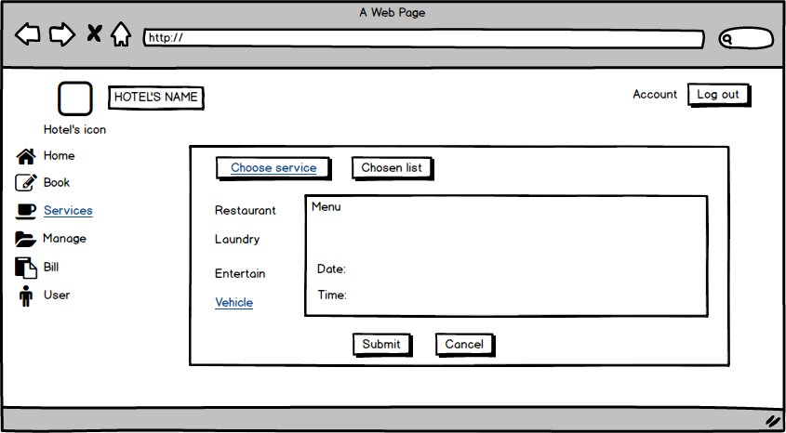

| **Screen** | Service Vehicle | | | | |
| --- | --- | --- | --- | --- | --- |
| **Description** | | Displays a list of the Service Vehicle. | | | |
| **Screen Access** | | Users click Submit, Cancel or Chosen list on Screen. | | | |
| **Screen Content** | | | | | |
| **Item** | | **Type** | **Data** | **Description** | |
| Menu | | Text | List menu | Display information of the list menu. | |
| Date | | Date | Day, month, year (d/m/y) | Display information of the day. | |
| Time | | Time | Time (h:m) | Display information of the year. | |
| Submit | | Button |  | Submit | |
| Cancel | | button |  | Cancel | |
| **Screen Actions** | | | | | |
| **Action Name** | | **Description** | | **Success** | **Failure** |
| Submit | | Click Submit to select menu list. | |  |  |
| Cancel | | Click Cancel to cancel | |  |  |
| Chosen list | | View chosen list | | Display a list of selected |  |

**+ Manage Staff**

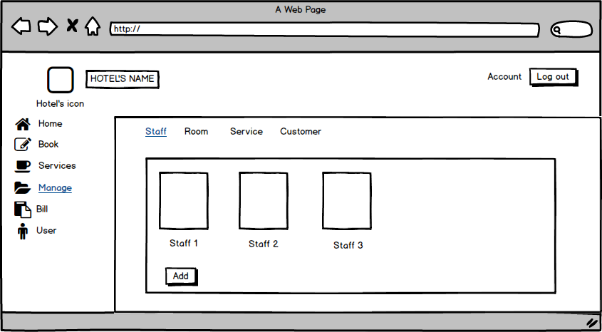

| **Screen** | Manage Staff | | | | |
| --- | --- | --- | --- | --- | --- |
| **Description** | | Displays a list Staff and add Staff. | | | |
| **Screen Access** | | Users click on add to add Staff | | | |
| **Screen Content** | | | | | |
| **Item** | | **Type** | **Data** | **Description** | |
| Staff 1 | | Text | information of Staff 1 | * Display information of Staff 1 | |
| Staff 2 | | Text | information of Staff 2 | * Display information of Staff 2 | |
| Staff 3 | | Text | information of Staff 3 | * Display information of Staff 3 | |
| Add | | Button |  | * User click on button to add Staff | |
| **Screen Actions** | | | | | |
| **Action Name** | | **Description** | | **Success** | **Failure** |
| Add | | User click on button to add Staff | | Display list of Staff. |  |

**+ Manage Staff (Add Staff)**

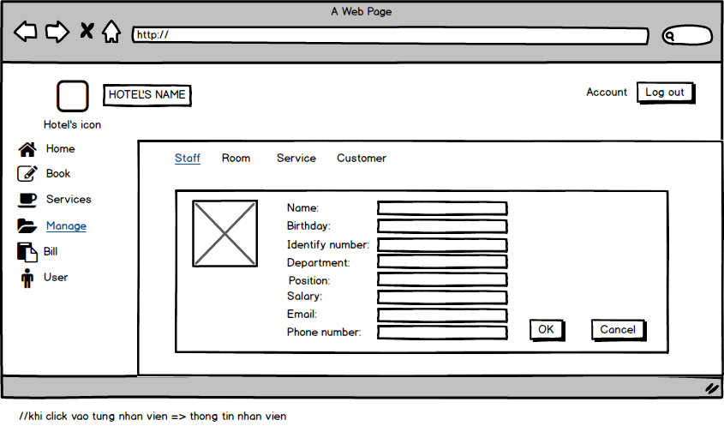

| **Screen** | Add Staff | | | | |
| --- | --- | --- | --- | --- | --- |
| **Description** | | Add Staff: Name, birthday, Email …… | | | |
| **Screen Access** | | Add information of Staff | | | |
| **Screen Content** | | | | | |
| **Item** | | **Type** | **Data** | **Description** | |
| Name | | Textbox | Name off staff | * User enter name | |
| Birthday | | Date | Dd/mm/yy | * User enter your birthday | |
| Identify number | | Number(15) | Number | * User enter Identify number | |
| Department | | Text | Department of staff | * User enter department | |
| Position | | Text | Position | * User enter your position | |
| Salary | | Number | Salary | * User enter your Salary | |
| Email | | text | email | * User enter your Email | |
| Phone Number | | Number | Phone number | * User enter your phone number | |
| Ok | | button |  | * User click to add | |
| Cancel | | button |  | * User click to cancel | |
| **Screen Actions** | | | | | |
| **Action Name** | | **Description** | | **Success** | **Failure** |
| Ok | | Users click Ok to agree to add information off staff. | | Display message “Ok”. | Display message “Failed”. |
| Cancel | | Users click cancel to not agree to add information off staff. | |  |  |

**+ Manage Staff (Edit Staff)**

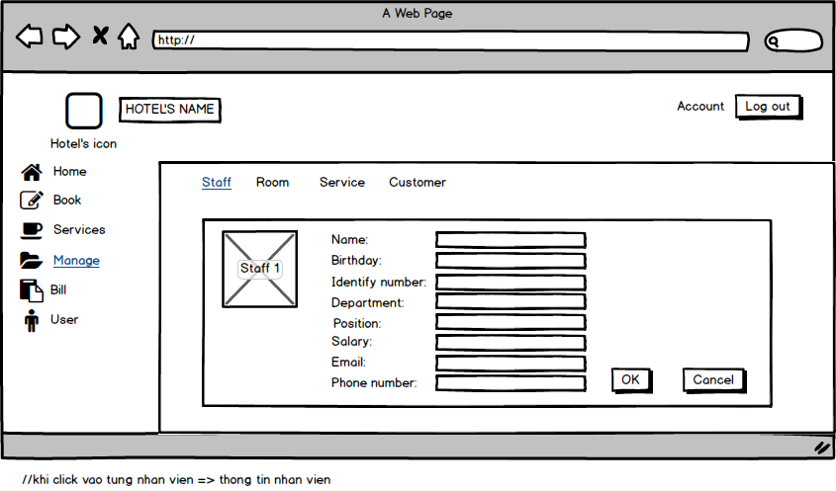

| **Screen** | Edit Staff | | | | |
| --- | --- | --- | --- | --- | --- |
| **Description** | | Edit Staff: Name, birthday, Email …… | | | |
| **Screen Access** | | Edit information of Staff | | | |
| **Screen Content** | | | | | |
| **Item** | | **Type** | **Data** | **Description** | |
| Name | | Textbox | Name off staff | * User enter name | |
| Birthday | | Date | Dd/mm/yy | * User enter your birthday | |
| Identify number | | Number(15) | Number | * User enter Identify number | |
| Department | | Text | Department of staff | * User enter department | |
| Position | | Text | Position | * User enter your position | |
| Salary | | Number | Salary | * User enter your Salary | |
| Email | | text | email | * User enter your Email | |
| Phone Number | | Number | Phone number | * User enter your phone number | |
| Ok | | Button |  | * User click to edit | |
| Cancel | | Button |  | * User click to cancel | |
| **Screen Actions** | | | | | |
| **Action Name** | | **Description** | | **Success** | **Failure** |
| Ok | | Users click Ok to agree to edit information off staff. | | Display message “Ok”. | Display message “Failed”. |
| Cancel | | Users click Ok to not edit information off staff. | |  |  |

**+ Manage Staff (View Staff)**

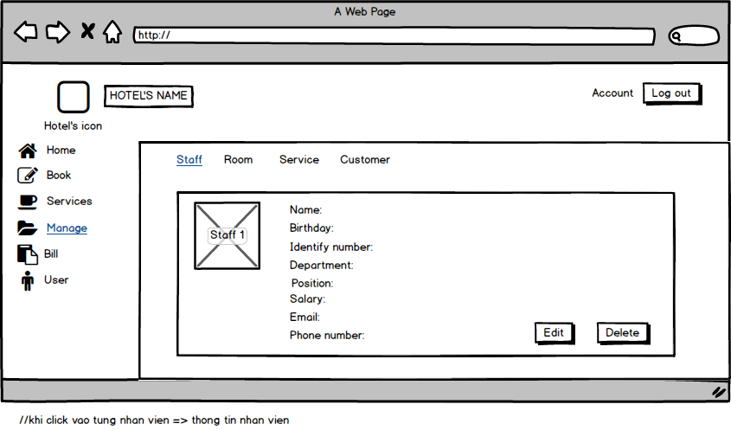

| **Screen** | View Staff | | | | |
| --- | --- | --- | --- | --- | --- |
| **Description** | | View Staff: Name, birthday, Email …… | | | |
| **Screen Access** | | View information of Staff | | | |
| **Screen Content** | | | | | |
| **Item** | | **Type** | **Data** | **Description** | |
| Name | | Textfield | Name off staff | * Displays name | |
| Birthday | | Date | Dd/mm/yy | * Displays birthday | |
| Identify number | | Number(15) | Number | * Displays Identify number | |
| Department | | Text | Department of staff | * Displays department | |
| Position | | Text | Position | * Displays position | |
| Salary | | Number | Salary | * Displays Salary | |
| Email | | Text | email | * Displays Email | |
| Phone Number | | Number | Phone number | * Displays phone number | |
| Edit | | Button |  | * User click to edit | |
| Delete | | Button |  | * User click to delete | |
| **Screen Actions** | | | | | |
| **Action Name** | | **Description** | | **Success** | **Failure** |
| Edit | | Users click Edit to edit. | |  |  |
| Delete | | User click delete to delete | |  |  |

**+ Manage Staff (Delete Staff)**

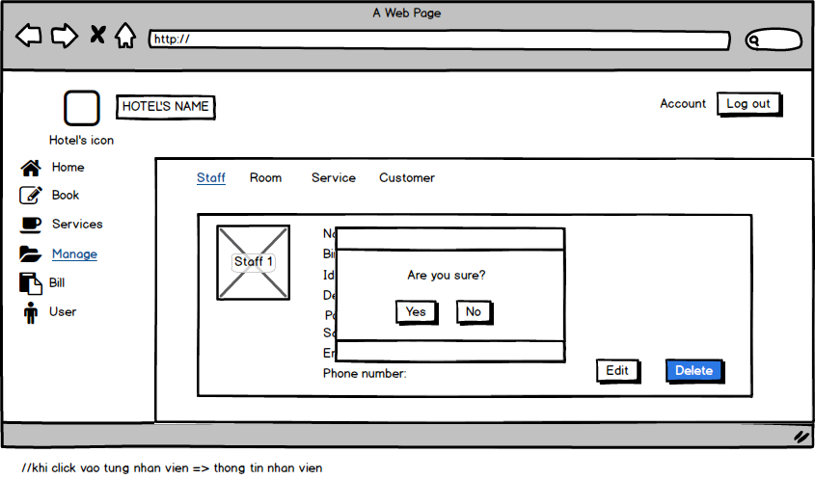

| **Screen** | Delete Staff | | | | |
| --- | --- | --- | --- | --- | --- |
| **Description** | | Delete Staff: Name, birthday, Email …… | | | |
| **Screen Access** | | Delete information of Staff | | | |
| **Screen Content** | | | | | |
| **Item** | | **Type** | **Data** | **Description** | |
| Name | | Textfield | Name off staff | * Displays name | |
| Birthday | | Date | Dd/mm/yy | * Displays birthday | |
| Identify number | | Number(15) | Number | * Displays Identify number | |
| Department | | Text | Department of staff | * Displays department | |
| Position | | Text | Position | * Displays position | |
| Salary | | Number | Salary | * Displays Salary | |
| Email | | Text | email | * Displays Email | |
| Phone Number | | Number | Phone number | * Displays phone number | |
| Yes | | Button |  | * User click to delete staff | |
| No | | Button |  | * User click to not delete staff | |
| **Screen Actions** | | | | | |
| **Action Name** | | **Description** | | **Success** | **Failure** |
| Yes | | User click to delete staff | | Display message “delete success”. |  |
| No | | User click to not delete staff | |  |  |

**+ Manage Room**

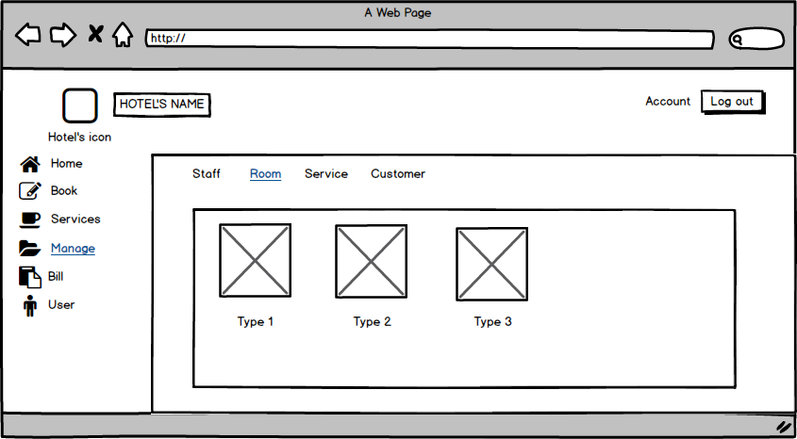

| **Screen** | Manage Room | |
| --- | --- | --- |
| **Description** | | Displays Room list and information |
| **Screen Access** | | View Room list and information |

**+ Manage Room (Add Room)**

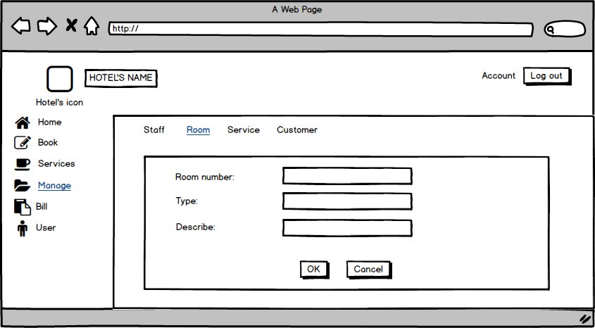

| **Screen** | Add Room | | | | |
| --- | --- | --- | --- | --- | --- |
| **Description** | | Add Room: Room number, type, Describe | | | |
| **Screen Access** | | Add information of Room | | | |
| **Screen Content** | | | | | |
| **Item** | | **Type** | **Data** | **Description** | |
| Room number | | Number | number | * enter number of room | |
| Type | | Text | Text | * enter type of room | |
| Describe | | Text | Text | * enter Describe of room | |
| Ok | | Button |  | * click to add room | |
| Cancel | | Button |  | * click to cancel | |
| **Screen Actions** | | | | | |
| **Action Name** | | **Description** | | **Success** | **Failure** |
| Ok | | User click Ok to agree add room | | Display message “Ok”. | Display message “Failed”. |
| Cancel | | User click cancel to cancel | |  |  |

**+ Manage Room (View Room)**

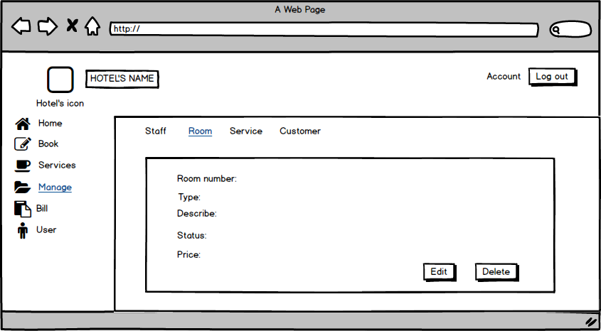

| **Screen** | View Room | | | | |
| --- | --- | --- | --- | --- | --- |
| **Description** | | View room: Room number, type, Describe, status, price | | | |
| **Screen Access** | | View information of Room | | | |
| **Screen Content** | | | | | |
| **Item** | | **Type** | **Data** | **Description** | |
| Room number | | Number | number | * Display number of room | |
| Type | | Text | Text | * Display type of room | |
| Describe | | Text | Text | * Display Describe of room | |
| Status | | Text | Text | * Displays status of room | |
| Price | | Number | Number | * Displays price of room | |
| Edit | | Button |  | * Click to edit | |
| Delete | | Button |  | * Click to delete | |
| **Screen Actions** | | | | | |
| **Action Name** | | **Description** | | **Success** | **Failure** |
| Edit | | User click Edit to edit. | |  |  |
| Delete | | User click delete to delete | |  |  |

**+ Manage Room (Edit Room)**

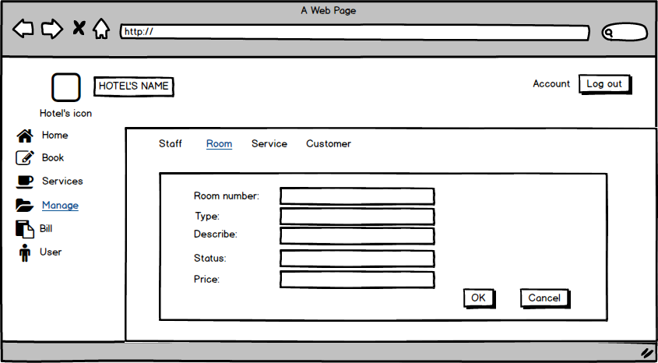

| **Screen** | Edit Room | | | | |
| --- | --- | --- | --- | --- | --- |
| **Description** | | Edit Room: Room number, type, Describe, status, price | | | |
| **Screen Access** | | Edit information of room | | | |
| **Screen Content** | | | | | |
| **Item** | | **Type** | **Data** | **Description** | |
| Room number | | Textbox | number | * enter number of room | |
| Type | | Textbox | Text | * enter type of room | |
| Describe | | Textbox | Text | * enter Describe of room | |
| Status | | Textbox | Text | * enter status of room | |
| Price | | Textbox | Number | * enter price of room | |
| Ok | | Button |  | * User click to edit | |
| Cancel | | Button |  | * User click to cancel | |
| **Screen Actions** | | | | | |
| **Action Name** | | **Description** | | **Success** | **Failure** |
| Ok | | Users click Ok to agree to edit information off room. | | Display message “Ok”. | Display message “Failed”. |
| Cancel | | Users click Ok to not edit information off the room. | |  |  |

**+ Manage Room (Delete Room)**

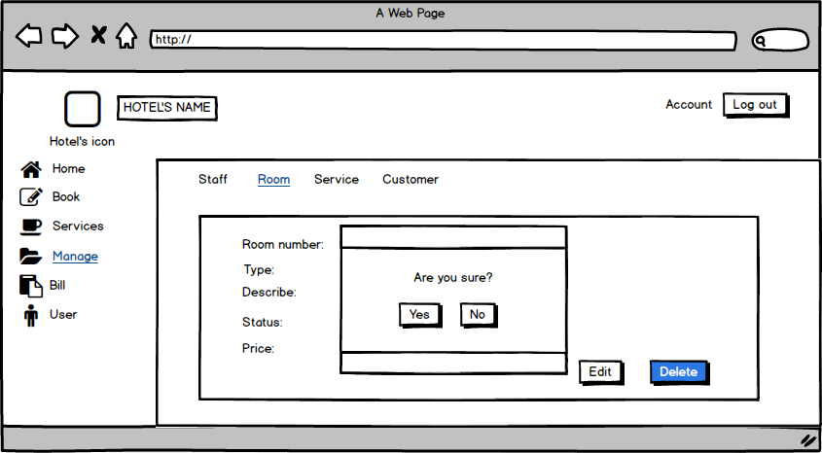

| **Screen** | Delete Room | | | | |
| --- | --- | --- | --- | --- | --- |
| **Description** | | Delete room: Room number, type, Describe, status, price | | | |
| **Screen Access** | | Delete information of room | | | |
| **Screen Content** | | | | | |
| **Item** | | **Type** | **Data** | **Description** | |
| Room number | | Textbox | number | * enter number of room | |
| Type | | Textbox | Text | * enter type of room | |
| Describe | | Textbox | Text | * enter Describe of room | |
| Status | | Textbox | Text | * enter status of room | |
| Price | | Textbox | Number | * enter price of room | |
| Yes | | Button |  | * User click to delete room | |
| No | | Button |  | * User click to not delete room | |
| **Screen Actions** | | | | | |
| **Action Name** | | **Description** | | **Success** | **Failure** |
| Yes | | User click to delete room | | Display message “delete success”. |  |
| No | | User click to not delete room | |  |  |

**+ Manage Service**

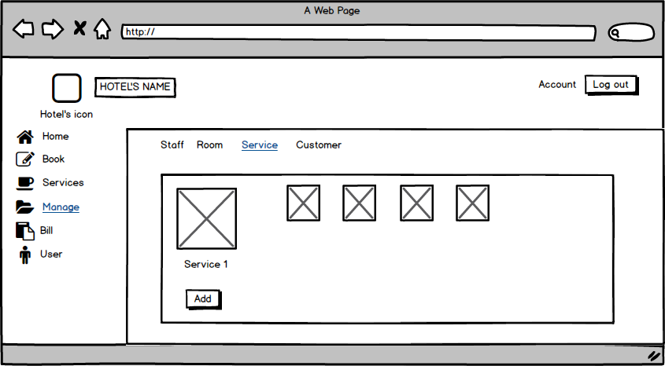

| **Screen** | Manage Service | | | | | |
| --- | --- | --- | --- | --- | --- | --- |
| **Description** | | Displays Service list and information for all the service of the Hotel. | | | | |
| **Screen Access** | | Click item Service on the menu Manage. | | | | |
| **Screen Content** | | | | | | |
| **Item** | | **Type** | **Data** | | **Description** | |
| Server1 | | link |  | | Server’s Name, link to Service information. | |
| Table List | | table |  | | Show list. The information and image about the server name. | |
| Add | | Button |  | | Add button, to add new Service | |
| **Screen Actions** | | | | | | |
| **Action Name** | | **Description** | | **Success** | | **Failure** |
| show service | | Show the information of all the service. | |  | |  |
| Add | | To add new service | | Show add service layout for you to input new service information. | | No action. |

**+ Manage Service (Add Service)**

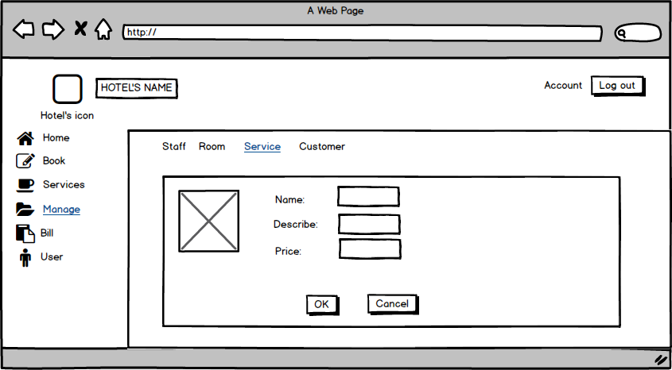

| **Screen** | Add new Service | | | | | |
| --- | --- | --- | --- | --- | --- | --- |
| **Description** | | Displays some textboxes to input text. | | | | |
| **Screen Access** | | Click the Add button from the service manager screen. | | | | |
| **Screen Content** | | | | | | |
| **Item** | | **Type** | **Data** | | **Description** | |
| Image | | Image |  | | Image for the Service | |
| Name | | textbx (text) |  | | Here get the service name that you're inputting. | |
| Describe | | textbox (text) |  | | You can describe something about the service. It will help the customer know what the service is? | |
| Price | | textbox (text) |  | | Input here how much the service cost. | |
| OK | | Button |  | | Click Ok to add the service to the service manager screen. | |
| Cancel | | Button |  | | Cancel button to destroy. | |
| **Screen Actions** | | | | | | |
| **Action Name** | | **Description** | | **Success** | | **Failure** |
| Input information | | Input text | |  | |  |
| Click OK button | | Click on the OK button | | Add the service into service management. | | No action or the service you were added does not display in the service manager. |
| Click Cancel | | Click on the Cancel button | | Return to service manage screen and nothing update. | | No action, or new service will be added to service management. |

**+ Manage Service (View Service)**

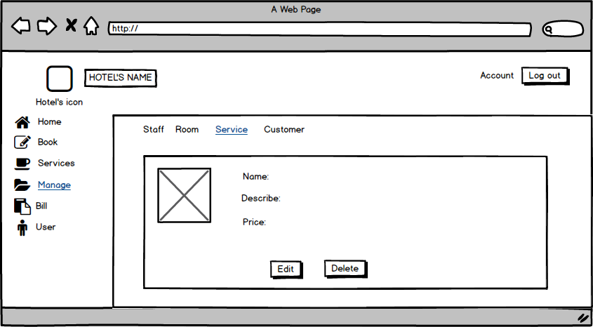

| **Screen** | View Service | | | | | |
| --- | --- | --- | --- | --- | --- | --- |
| **Description** | | Displays the service | | | | |
| **Screen Access** | | Click service name (link). | | | | |
| **Screen Content** | | | | | | |
| **Item** | | **Type** | **Data** | | **Description** | |
| Image | | Image |  | | Image for the Service | |
| Name | | Label (text) |  | | Show the service name. | |
| Describe | | Label (text) |  | | Show what you were described for the service. | |
| Price | | Label (text) |  | | Show the price that you were input. | |
| Edit | | Button |  | | Go to the Edit screen to change the information for the service. | |
| Delete | | Button |  | | Delete the service form service manager. | |
| **Screen Actions** | | | | | | |
| **Action Name** | | **Description** | | **Success** | | **Failure** |
| Click Edit button | | Click on the Edit button to change service name, service cost or service description. | | Show the Edit screen for you to change the information. | | No action. |
| Click delete | | Click on the delete button. | | Show a message box to check your decision. | | No action. |

**+ Manage Service (Edit Service)**

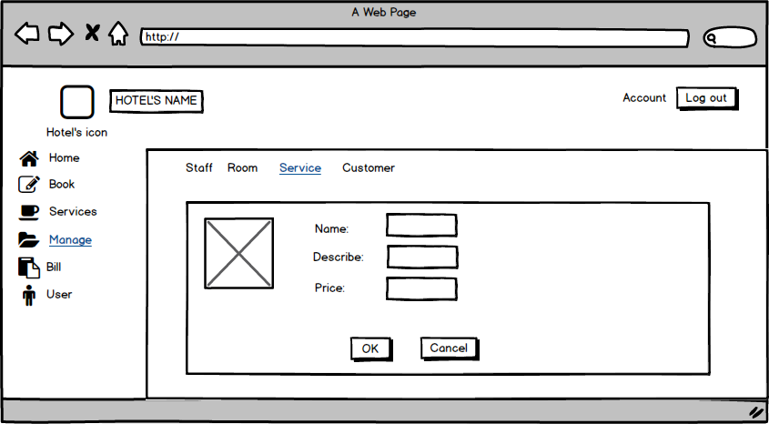

| **Screen** | Edit Screen | | | | | |
| --- | --- | --- | --- | --- | --- | --- |
| **Description** | | Show the old information of the service, but you can change the text. | | | | |
| **Screen Access** | | Click the Edit button from the View service screen. | | | | |
| **Screen Content** | | | | | | |
| **Item** | | **Type** | **Data** | | **Description** | |
| Image | | Image |  | | Image for the Service | |
| Name | | Textbox (text) |  | | Show the service name, (can change) | |
| Describe | | Textbox (text) |  | | Show what you were described for the service. (can change) | |
| Price | | Textbox (text) |  | | Show the price that you were inputting. (can change) | |
| OK | | Button |  | | Click Ok to change and update new information about the service. | |
| Cancel | | Button |  | | To dispose of the change. | |
| **Screen Actions** | | | | | | |
| **Action Name** | | **Description** | | **Success** | | **Failure** |
| Change text | | Retype new text into the textbox. | |  | |  |
| Click OK button | | Click on the OK button to change service name, service cost or service description. | | Update and show the change in service management screen. | | No action. |
| Click Cancel | | Click on the Cancel button. | | Show a message box to check your decision. | | No action. |

**+ Manage Service (Delete Service)**

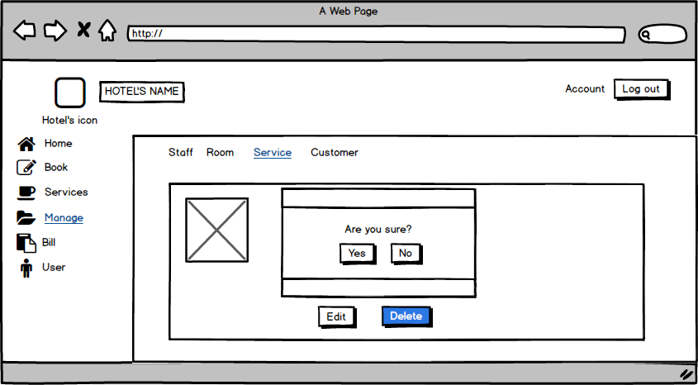

| **Screen** | Edit Screen | | | | | |
| --- | --- | --- | --- | --- | --- | --- |
| **Description** | | Show the old information of the service, but you can change the text. | | | | |
| **Screen Access** | | Click the Delete button from the View service screen. | | | | |
| **Screen Content** | | | | | | |
| **Item** | | **Type** | **Data** | | **Description** | |
| Image | | Image |  | | Image for the Service | |
| Message Box | |  | OS | | Show a msgbox with a text “Are you sure” | |
| Yes | | Button |  | | To confirm you accept to delete the service. | |
| No | | button |  | | To confirm you don’t allow me to delete the service. | |
| **Screen Actions** | | | | | | |
| **Action Name** | | **Description** | | **Success** | | **Failure** |
| Show msgbox | | A message box will show with the text. | | Show the text | | No action. |
| Click Yes button | | Click on the Yes button to confirm the service will be deleted. | | update and no see the service into service manage screen. The message box disappeared. | | The service is still in the service manager screen. |
| Click No | | Click on the No button. | | Show a message box to check your decide. The message box disappeared. | | No action. |

**+ Manage Customer**

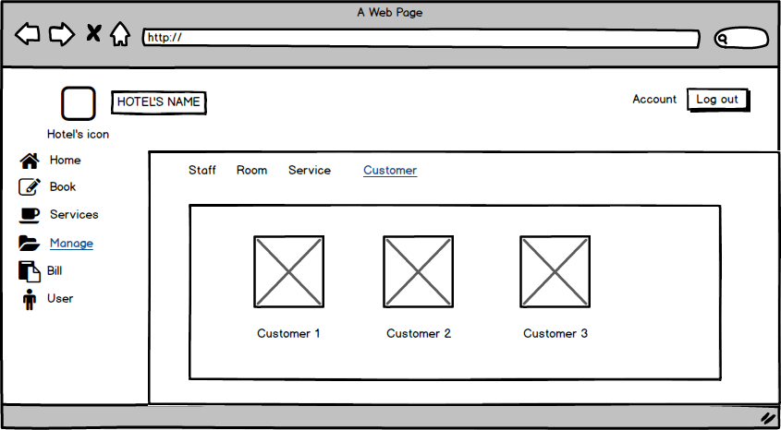

| **Screen** | Manage Customer | | | |
| --- | --- | --- | --- | --- |
| **Description** | | Show the customer information ( image and name) | | |
| **Screen Access** | | Click item Customer on the menu Manage. | | |
| **Screen Content** | | | | |
| **Item** | | **Type** | **Data** | **Description** |
| Image | | Image |  | Image for the Service |
| Customer1 | | link | Customer’s name | Link to Customer’s information. |

**+ Manage Customer (Add Service)**



**+ Manage Customer (View Customer)**

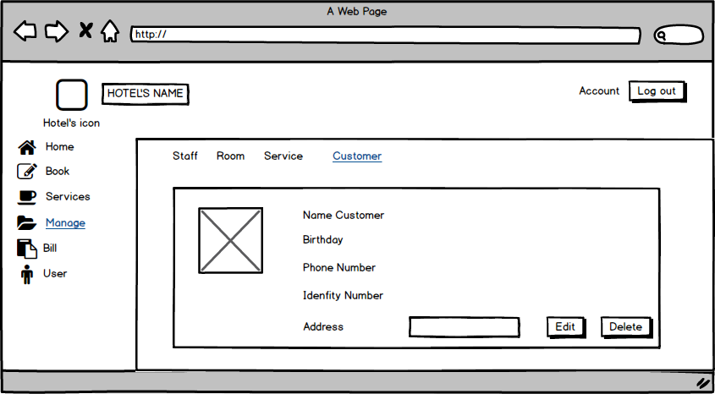

| **Screen** | View Customer | | | | | |
| --- | --- | --- | --- | --- | --- | --- |
| **Description** | | Show the customer information . | | | | |
| **Screen Access** | | Click Customer name (link) From customer manage. | | | | |
| **Screen Content** | | | | | | |
| **Item** | | **Type** | **Data** | | **Description** | |
| Image | | Image |  | | Image for the Service | |
| Name Customer | | Label (text) |  | | Show Name Customer | |
| Birthday | | Label (text) |  | | Show customer birthday. | |
| Phone number | | Label (text) |  | | Show phone number | |
| Identity number | | Label (text) |  | | Show identity number | |
| address | | Label |  | | Show customer address. | |
| Edit | | Button |  | | To edit Customer information | |
| Delete | | Buton |  | | To delete Customer | |
| **Screen Actions** | | | | | | |
| **Action Name** | | **Description** | | **Success** | | **Failure** |
| Click Edit button | | Click on the Edit button to edit customer information. | | Show Edit customer Screen | | No action. |
| Click Delete button | | Click on the delete button to delete customers. | | The customer will be deleted from the Customer manage screen. | | No action, Or the information of the customer not be deleted. |

**+ Manage Customer (Edit Customer)**

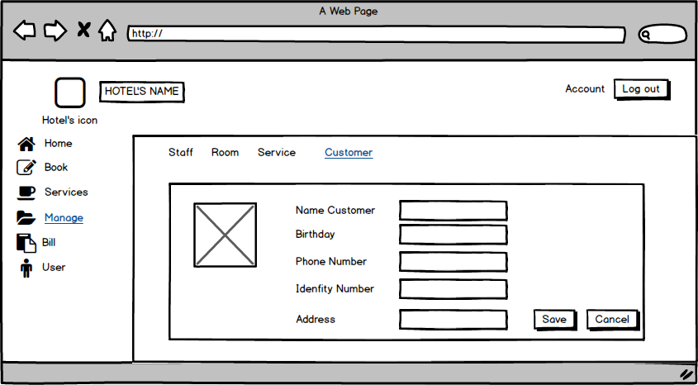

| **Screen** | Edit Customer Screen. | | | | | |
| --- | --- | --- | --- | --- | --- | --- |
| **Description** | | Show the customer information, and the textbox for change. | | | | |
| **Screen Access** | | Click the Edit button from the Customer View Screen. | | | | |
| **Screen Content** | | | | | | |
| **Item** | | **Type** | **Data** | | **Description** | |
| Image | | Image |  | | Show Image, Edit image | |
| Name Customer | | TextBox (text) |  | | Edit Name here | |
| Birthday | | TextBox (text) |  | | Edit customer birthday. | |
| Phone number | | TextBox (text) |  | | Edit phone number | |
| Identity number | | TextBox (text) |  | | Show identity number | |
| address | | TextBox (text) |  | | Edit customer address. | |
| Save | | Button |  | | To save and update Customer information | |
| Cancel | | Buton |  | | Exit and return to customer view screen | |
| **Screen Actions** | | | | | | |
| **Action Name** | | **Description** | | **Success** | | **Failure** |
| Click Save button | | Click on the save button to save customer information. | | Update customer information on customer management. | | No action. |
| Click Cancel button | | Click on the Cancel button to exit. | | Return View Customer Screen. | | No action. |

**+ Manage Customer (Delete Customer)**

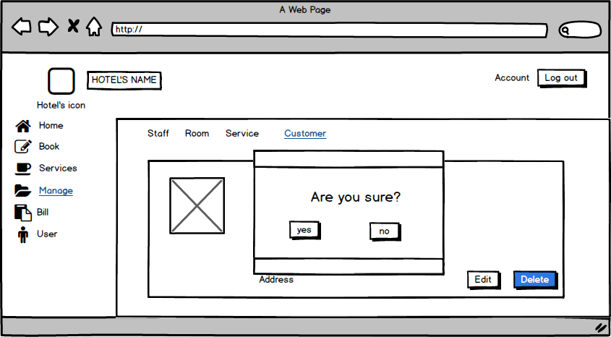

| **Screen** | Edit Customer Screen. | | | | | |
| --- | --- | --- | --- | --- | --- | --- |
| **Description** | | Show the customer information, and the textbox for change. | | | | |
| **Screen Access** | | Click Delete button from Customer View Screen. | | | | |
| **Screen Content** | | | | | | |
| **Item** | | **Type** | **Data** | | **Description** | |
| Image | | Image |  | | Show Image, Edit image | |
| Message box | |  |  | | Show message box | |
| Yes | | Button |  | | To confirm, you want to delete the customer information. | |
| No | | Buton |  | | Exit and return to customer view screen | |
| **Screen Actions** | | | | | | |
| **Action Name** | | **Description** | | **Success** | | **Failure** |
| Click Yes button | | Click on the Yes button . | | The customer will delete. The information about the customer who was deleted will not show in customer management. | | No action. |
| Click No button | | Click on the No button | | Return View Customer Screen. | | No action. |

**+ Bill**

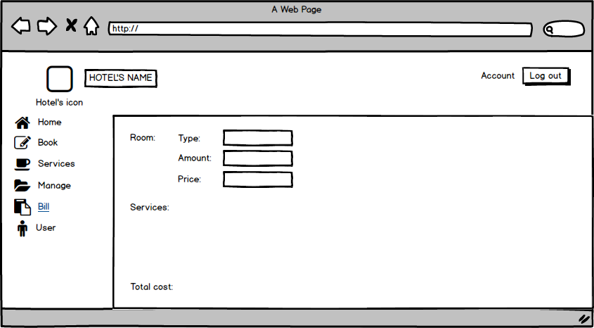

| **Screen** | Bill | | | |
| --- | --- | --- | --- | --- |
| **Description** | | Display information about type, amount, price of room and total cost. | | |
| **Screen Access** | | View information | | |
| **Screen Content** | | | | |
| **Item** | | **Type** | **Data** | **Description** |
| Type (Room) | | Text field | Type of room | * Display information about type of room |
| Amount (Room) | | Number | Number of room | * Display Number of room |
| Price (Room) | | Number | Price | * Display Price |
| Services | | Text field | Service list | * Display Service list |
| Total cost | | Number | Total cost | * Display Total cost |

**+ User**

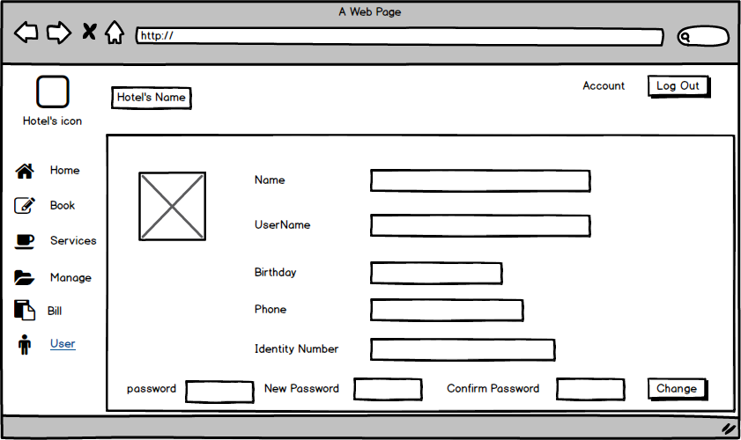

| **Screen** | User | | | |
| --- | --- | --- | --- | --- |
| **Description** | | This will show you : your name, your user name, password,Birthday, phone, Identity number. You also can change your password here if you want. | | |
| **Screen Access** | | Click edit item from Book menu | | |
| **Screen Content** | | | | |
| **Item** | | **Type** | **Data** | **Description** |
| name | | Text field | Export from database | * Show your full name |
| User name | | Tex field | Export from database | * Show your user name when you register with OS |
| Birthday | | Tex field | Export from database | * Your birthday will show here. You should type exactly your birthday to receive gifts from the hotel manager for your birthday. |
| phone | | Tex field | Export from database | * Your cell phone number show here |
| Identity Number | | Tex field | Export from database | * Your identity to confirm yourself to us. |
| password | | Text box | Insert your current password | * Text box here for you to insert your current password. |
| New password | | Text box | Insert text | * New password for your account |
| Confirm password | | Text box | Insert text | * New password for your account. |
| Change | | button |  | * Click it to change your password. |

# **DATA STRUCTURE**

## ***Entity diagram***

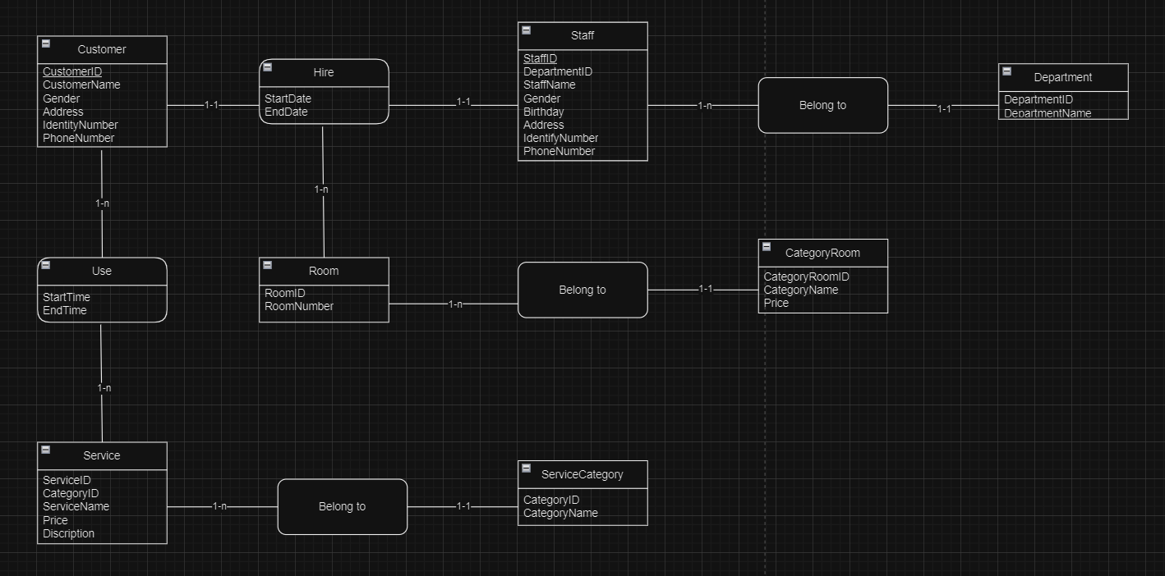

## ***Database***

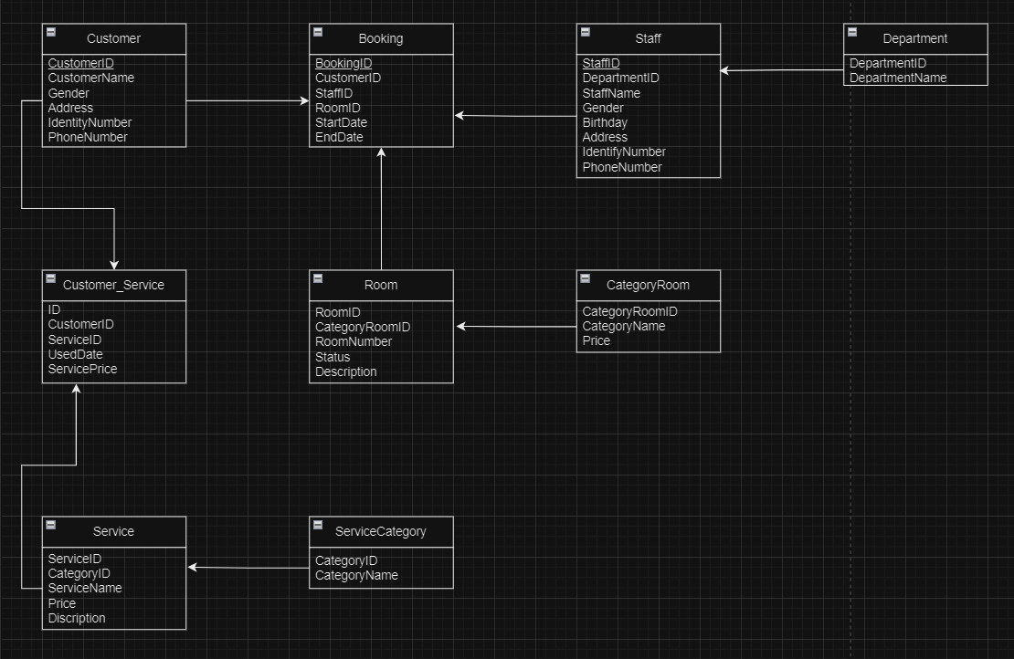

Null = Yes: allow empty value.

Null = No: disallow empty value.

PK: primary key.

FK: foreign key.

Int: 4-byte integer type.

Char: character type.

Money: monetary data types 8 bytes.

DateTime: date data type 8 bytes.

Nvarchar: Unicode data type.

| ROOM | | | | |
| --- | --- | --- | --- | --- |
| Field name | Data type | Null | Key | Note |
| RoomID | Int(4) | No | PK |  |
| CategoryRoomID | Int(4) | No | FK |  |
| Room number | Int(4) | No |  |  |
| Status | Char(1) | No |  | E: empty room  R: reserved room  B: busy room |
| Describe | Nvarchar(70) | Yes |  |  |

| ROOM CATEGORY | | | | |
| --- | --- | --- | --- | --- |
| Field name | Data type | Null | Key | Note |
| CategoryRoomID | Int(4) | No | PK |  |
| CategoryName | Char(8) | No |  |  |
| Price | Money(8) | No |  | Price(VND) |

| SERVICE | | | | |
| --- | --- | --- | --- | --- |
| Field name | Data type | Null | Key | Note |
| ServiceName | Int(4) | No |  |  |
| ServiceID | Int(4) | No | PK |  |
| Price | Float | No |  | Price(VND) |
| Describe | Nvarchar(70) | Yes |  |  |

| SERVICE CATEGORY | | | | |
| --- | --- | --- | --- | --- |
| Field name | Data type | Null | Key | Note |
| CategoryID | Int(4) | No | PK |  |
| CategoryName | Varchar(20) | No |  |  |

| STAFF | | | | |
| --- | --- | --- | --- | --- |
| Field name | Data type | Null | Key | Note |
| StaffID | Int(4) | No | PK |  |
| DepartmentID | Int(4) | No | FK |  |
| StaffName | Nvarchar(20) | No |  |  |
| Gender | Char(1) | No |  | O: male  X: female |
| Birthday | DateTime(8) | Yes |  |  |
| Address | Nvarchar(20) | Yes |  |  |
| IdentityNumber | Int(9) | No |  |  |
| PhoneNumber | Int(11) | Yes |  |  |

| DEPARTMENT | | | | |
| --- | --- | --- | --- | --- |
| Field name | Data type | Null | Key | Note |
| DepartmentID | Int(4) | No | PK |  |
| DepartmentName | Nvarchar(20) | No |  |  |

| CUSTOMER | | | | |
| --- | --- | --- | --- | --- |
| Field name | Data type | Null | Key | Note |
| CustomerID | Int(4) | No | PK |  |
| CustomerName | Nvarchar(20) | No |  |  |
| Gender | Char(1) | No |  | O: male  X: female |
| Address | Nvarchar(20) | Yes |  |  |
| IdentityNumber | Int(9) | Yes |  |  |

| BOOKING | | | | |
| --- | --- | --- | --- | --- |
| Field name | Data type | Null | Key | Note |
| BookingID | Int(4) | No | PK |  |
| CustomerID | Int(4) | No | FK |  |
| StaffID | Int(4) | No | FK |  |
| RoomID | Int(4) | No | FK |  |
| StartDate | DateTime(8) | No |  |  |
| EndDate | DateTime(8) | No |  |  |

| CUSTOMER_SERVICE | | | | |
| --- | --- | --- | --- | --- |
| Field name | Data type | Null | Key | Note |
| ID | Int(4) | No | PK |  |
| CustomerID | Int(4) | No | FK |  |
| ServiceID | Int(4) | No | FK |  |
| ServicePrice | Float | No |  |  |

# **NON-FUNCTIONAL REQUIREMENTS AND OTHERS**

Performance

| **No.** | **Requirement** |
| --- | --- |
| 1. | The load time for user interface screens shall take no longer than two seconds. |
| 2. | The log in information shall be verified within five seconds. |
| 3. | Queries shall return results within five seconds. |

Security

| **No.** | **Requirement** |
| --- | --- |
| 1. | Customer Service Representatives and Managers will be able to log in to the Hotel Management System. |
| 2. | Customer Service Representatives will have access to the Reservation/Booking and Food subsystems |
| 3. | Managers will have access to the Management subsystem as well as the Reservation/Booking and Food subsystems |
| 4. | Access to the various subsystems will be protected by a user log in screen that requires a user name and password |

Design Constraints

| **No.** | **Requirement** |
| --- | --- |
| 1. | The Hotel Management System shall be a stand-alone system running in a Windows environment. |
| 2. | The system shall be developed using PHP and an MySQL database. |

Standards Compliance

| **No.** | **Requirement** |
| --- | --- |
| 1. | There shall be consistency in variable names within the system. The graphical user interface shall have a consistent look and feel. |

Reliability

| **No.** | **Requirement** |
| --- | --- |
| 1. | Specify the factors required to establish the required reliability of the software system at time of delivery |

Availability

| **No.** | **Requirement** |
| --- | --- |
| 1. | The system shall be available during normal hotel operating hours. |

Maintainability

| **No.** | **Requirement** |
| --- | --- |
| 1. | The Hotel Management System is being developed in PHP. PHP is an object oriented programming language and shall be easy to maintain. |

Portability

| **No.** | **Requirement** |
| --- | --- |
| 1. | The Hotel Management System shall run in any Microsoft Windows environment that contains the MySQL database |

Hardware

| **Type** | Tower |
| --- | --- |
| **CPU** | 1 x Xeon E3-1225v3 (3.2Ghz-1600Mhz-8Mb) |
| **Max CPU** | 1 |
| **RAM** | 4Gb 4 x UDIMM, 1600 MT/s Slots |
| **Disk** | 1Tb |
| **NIC** | Ethernet Gigabit |
| **Slot** | 4 x PCIe slots |
| **Power** | 290W |
| **Max power supply** | 1 |

# 